# DOCKER TASK

# install docker on openSUSE 16 using the official documentation:

# https://en.opensuse.org/Docker

zypper install docker docker-compose docker-compose-switch

sudo systemctl enable docker

sudo usermod -G docker -a $USER

newgrp docker

sudo systemctl restart docker

# docker version to check

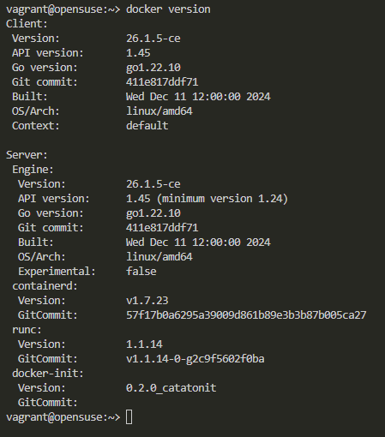

# after that, after some research in docker hub

docker run -it --name customSUSE opensuse/leap /bin/bash

# the image is very light, so there is no sudo, there is nothing.

zypper install sudo

sudo zypper refresh

sudo zypper update

sudo zypper install apache2

sudo zypper install apache2-utils

sudo zypper install vi

# add ServerName localhost

sudo mkdir /srv/www/htdocs/default

echo '<h1>SoftUni @chebishev is here!</h1>' | sudo tee /srv/www/htdocs/default/index.html

<h1>SoftUni @chebishev is here!</h1>

# add Document root to /etc/apache2/vhosts.d/000-default.conf

sudo vi /etc/apache2/vhosts.d/000-default.conf

DocumentRoot "/srv/www/htdocs/default"

sudo apache2ctl -D BACKGROUND

# so we have the apache server in there. Now we have to run the container with exposing its port to the parent machine

# the name of the container is customSUSE

docker start customSUSE

docker exec -it customSUSE /bin/bash -c "sudo apache2ctl -D BACKGROUND"

# the apache server must be running, but i still need the ip of the container

docker inspect -f '{{range .NetworkSettings.Networks}}{{.IPAddress}}{{end}}' customSUSE

# it returns 172.17.0.2

